Chapter 5 Hands-on MIS
Improving Decision Making: Using a Spreadsheet to Evaluate Hardware and Software Options

Desktop and Printer Specifications

Each desktop system must satisfy the minimum specifications shown in the following table:

MINIMUM DESKTOP SPECIFICATIONS
Processor speed 3 GHz
Hard drive 500 GB
RAM 4 GB
DVD-ROM drive DVD-RW
Monitor (diagonal measurement) 18 inches

Each desktop printer must satisfy the minimum specifications shown in the

MINIMUM MONOCHROME PRINTER SPECIFICATIONS
Print speed (black and white) 20 pages per minute
Print resolution 600 × 600
Network ready? Yes
Maximum price/unit $700

Steps to achieving the goal of finding the best computer and printer with the best prices and specifications.

The raw data looks as below
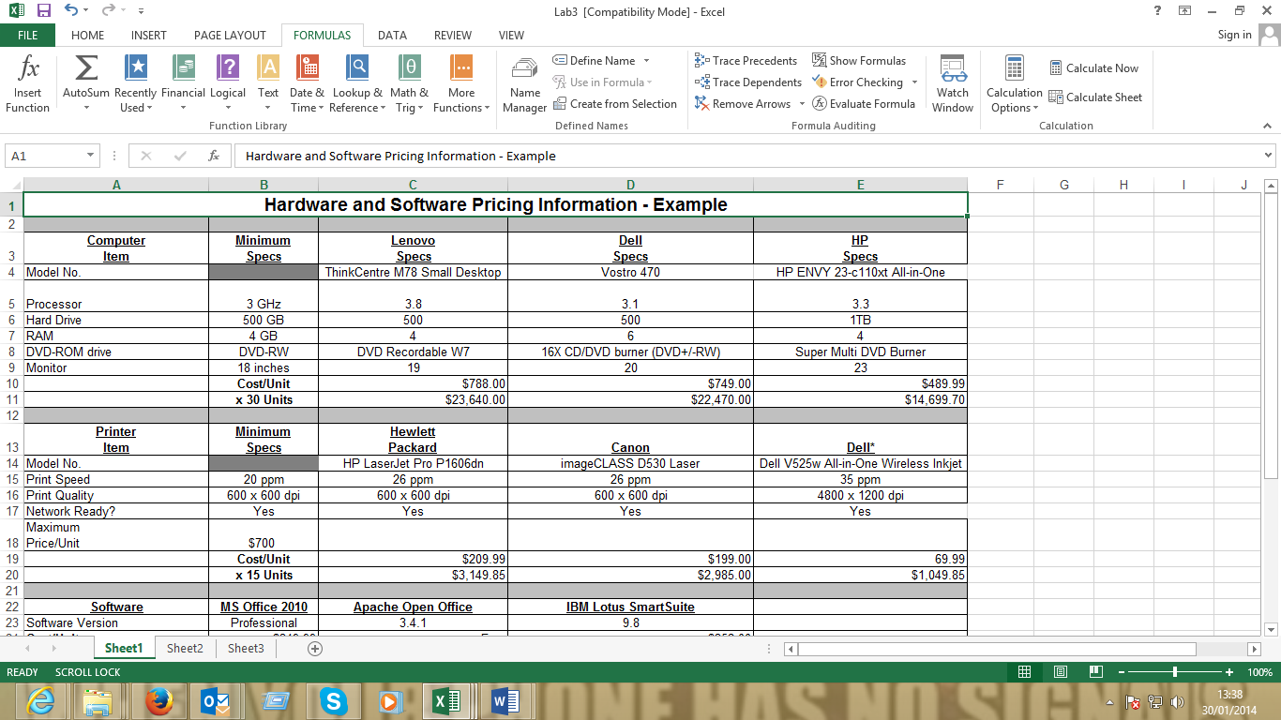
Rearranging Data
- The data is not arranged accordingly the numbers are mixed with characters therefore formulas will not work if applied to this spreadsheet as it is. Rearrange the data as shown in the diagram Frpm the minimum specs column remove the description (e.g. 500 GB—remove the GB) let it remain with number values only. Convert E6 to GB which translates to 1000.
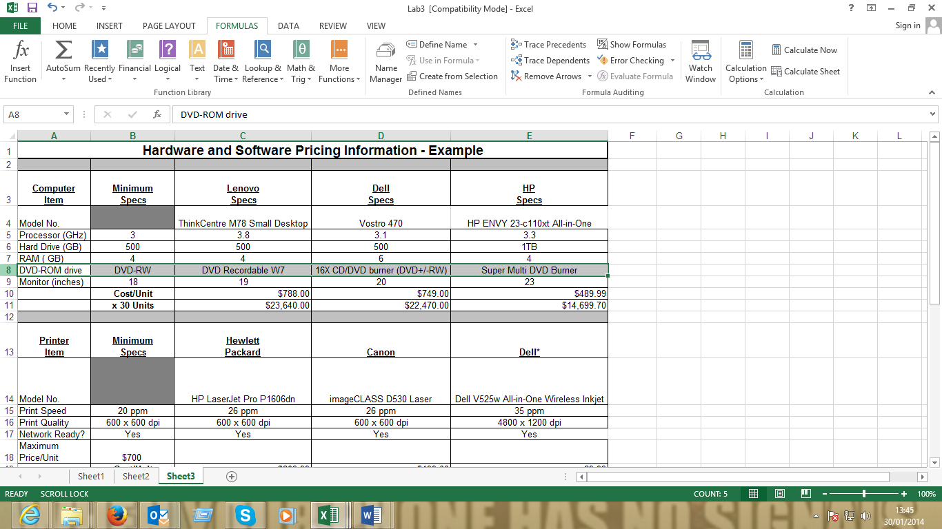
- Move row 8 contents to row 12. Then select row 9 to 12 and drag them up one cell to look as below
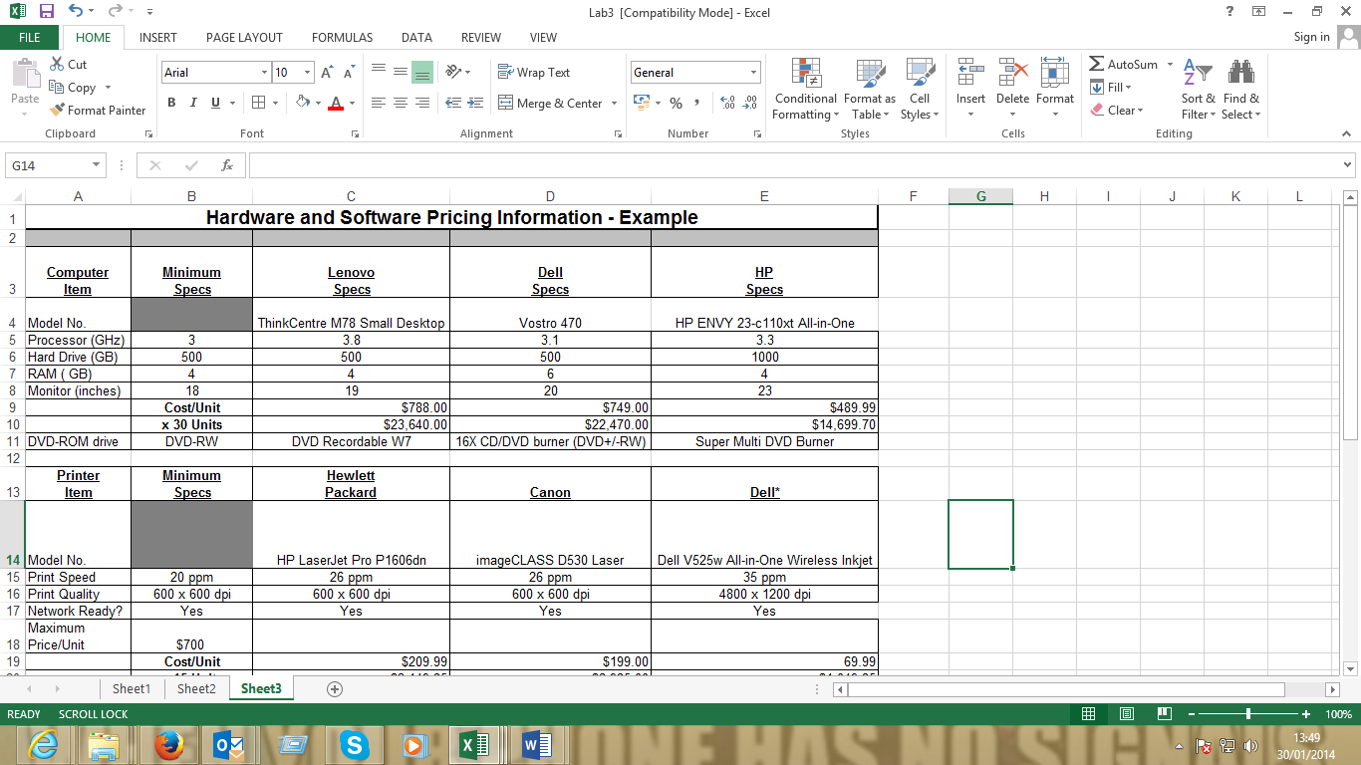

- Move row 17 contents to row 21. Then select cell C17:E17 and drag them up one cell to look as below. Delete the Cost/Unit under the minimum specs column row B18. Then drag cell contents of B19 to B18 as shown below. Drag row 20 to row 19 (network ready ) as shown.

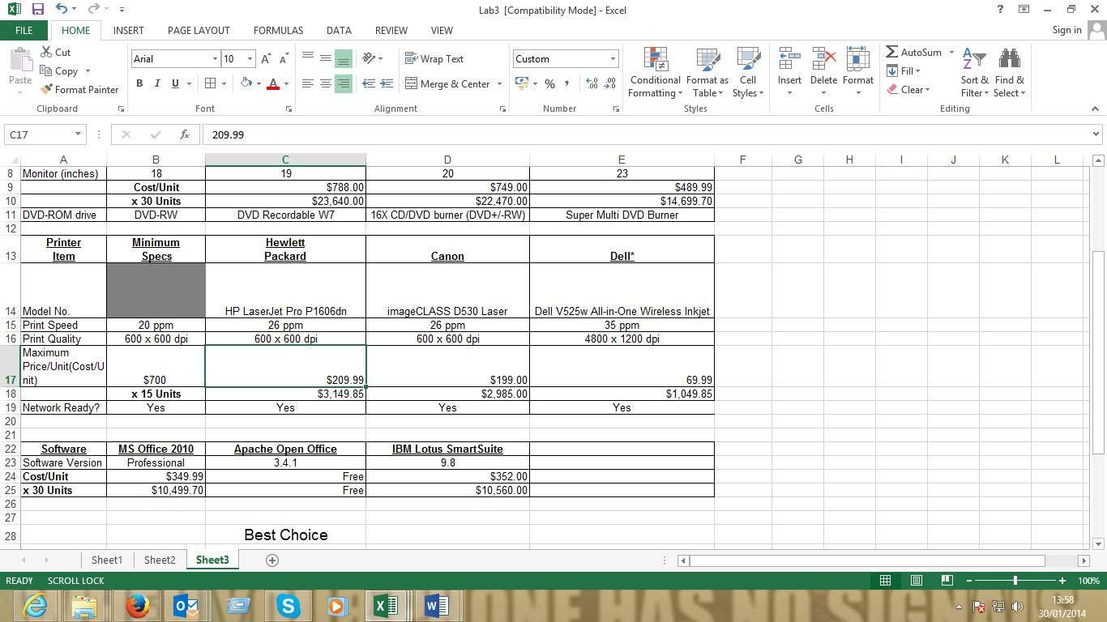

- The data is arranged therefore we are ready to start the steps to finding best prices.
Data Manipulation
- Rename cell F3, G3 and H3 as shown in the diagram. These are the cells that would be used to calculate the best models, specifications, and prices.
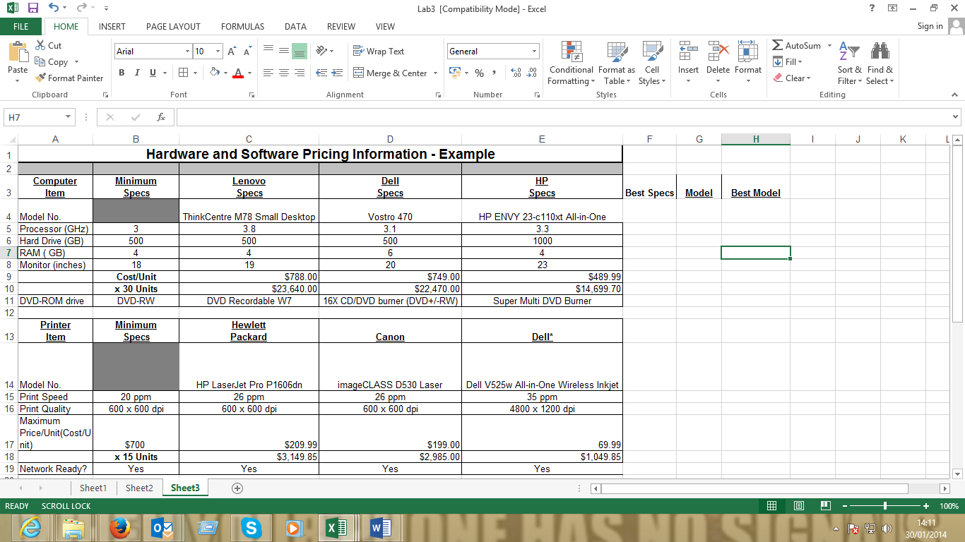
- We need to find the best specification. We use the MAX function for this. Select cell F5 and enter the following formula
=MAX(C5:E5)
It picks the highest value for processor speed. Drag the formula until cell E8. Should display results for the best specs for each item like the below results
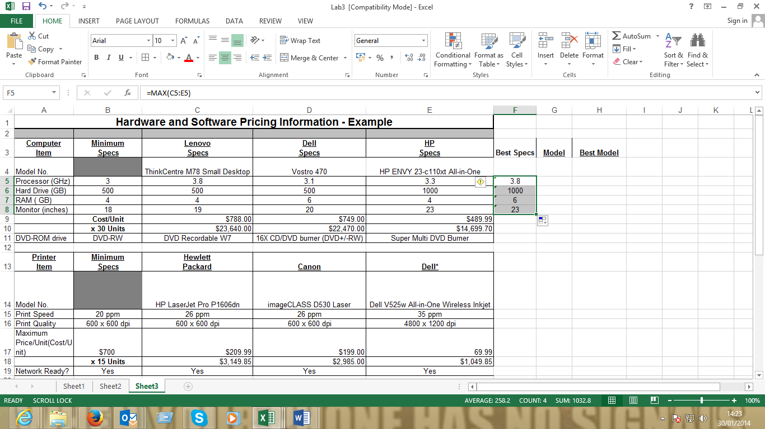

- As for the cost/Unit and Number of units. Best price would be the lowest price. For this we will use the MIN function to evaluate this. Select cell F9 and enter the following formula
=MIN(C9:E9)
Drag the formula to cell F10. The values are now complete for the computer specification.
- We need now to associate these values of best specifications with the Models available. In this step we will use the Match and Index function in excel to achieve our desired results. To determine which model has that best price and specification use the INDEX and MATCH functions.
To do this Select cell G5 and enter the following formula
=MATCH(F5,C5:E5,0)
Drag the formula to cell G10.The Model column should show the column numbers as shown below
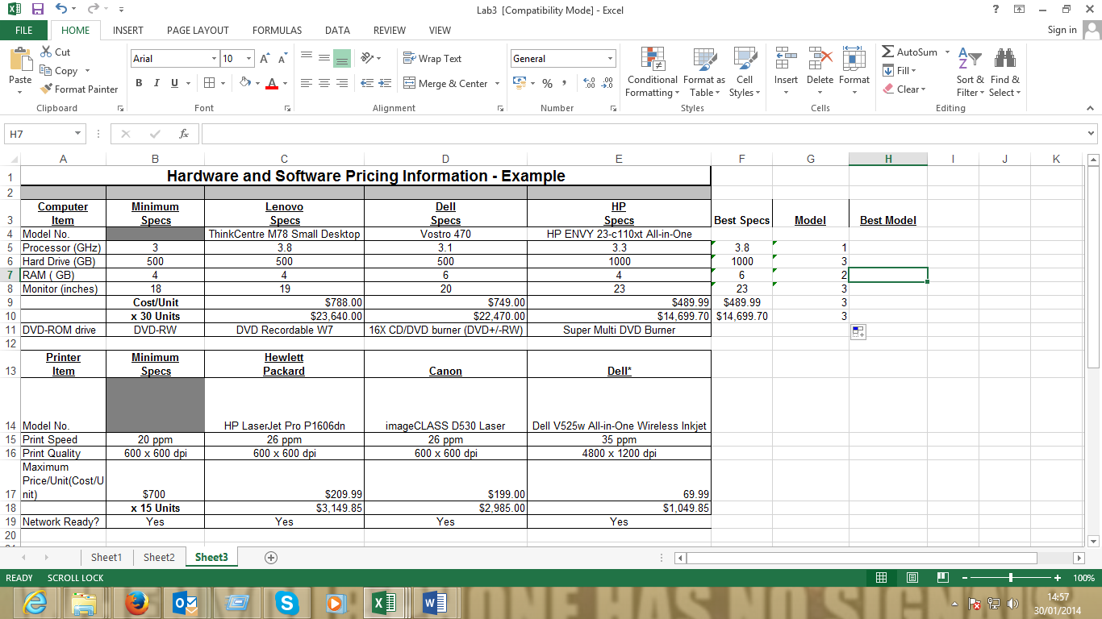
- We now need to associate the column number to the column name for that we use the INDEX function. Like we need to determine what the number 1 stands for.
Enter the following formula in cell F5
=INDEX(C$3:E$3,MATCH(F5,C5:E5,0))
It should now display the actual model. Drag the formula to cell G10.

Drag the formula to cell F10.
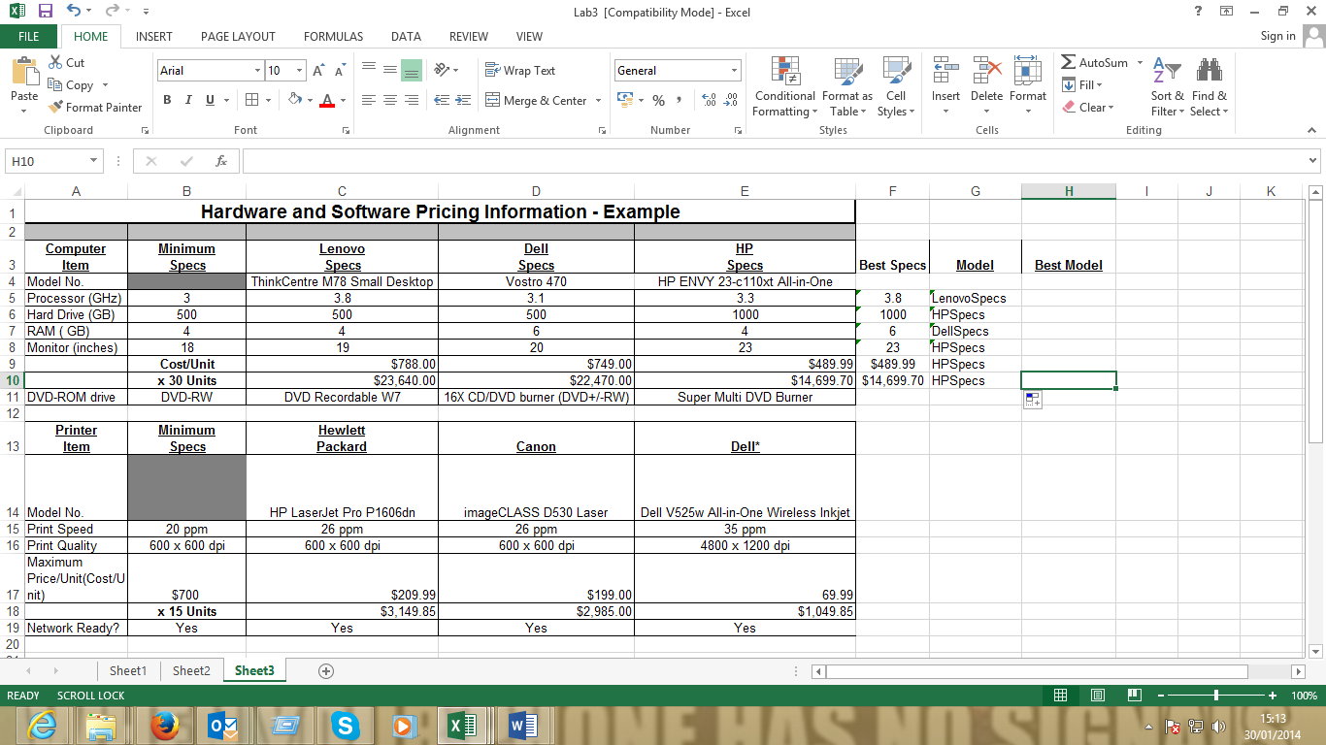

- The next step is to detarmine the best model with the most desireable specification and price.
In this step we will use the MATCH INDEX function and also use the MOD.MULT function. The MOD.MULT function is used to determine the frequency in which each item appears on the list. In our case we need to determine the occurrence of the different models with regard to specifications.
Select Cell H5.
Enter the following formula
=INDEX(G5:G10,MODE.MULT(MATCH(G5:G10,G5:G10,0)))

Index function finds the column, the MOD function finds the frequency in occurrence and he match function associates the elements to exact value
The result should be as below
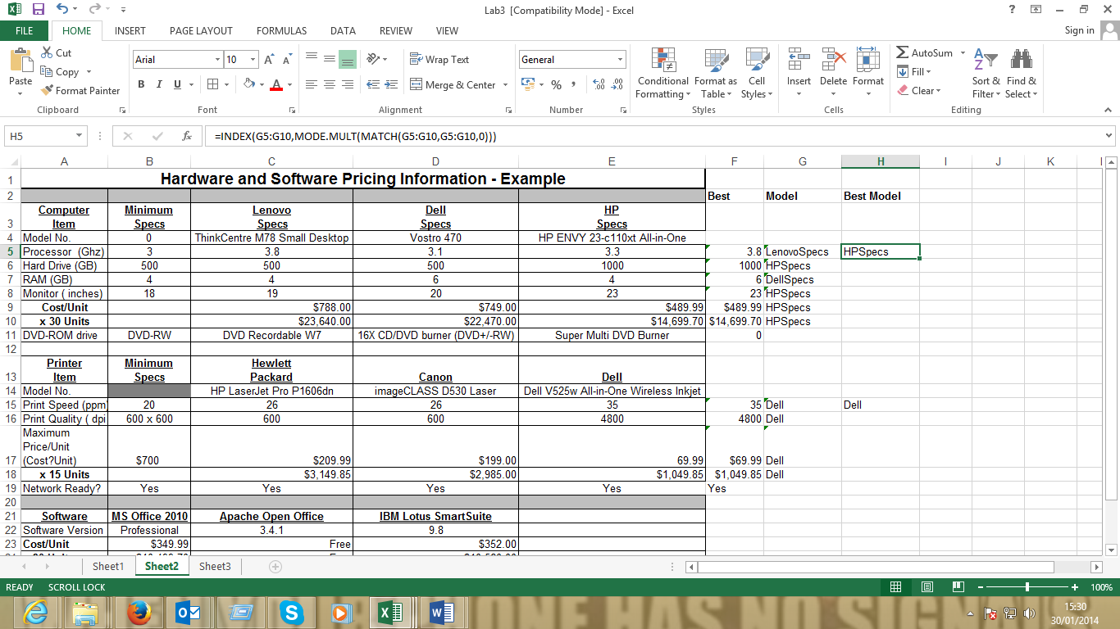

The best Model of computer is HP with the best specifications
Task: Determinie the best Printer with Specifications
Determine the best operating System

